The screen shot below shows the successful run on the filebeat:

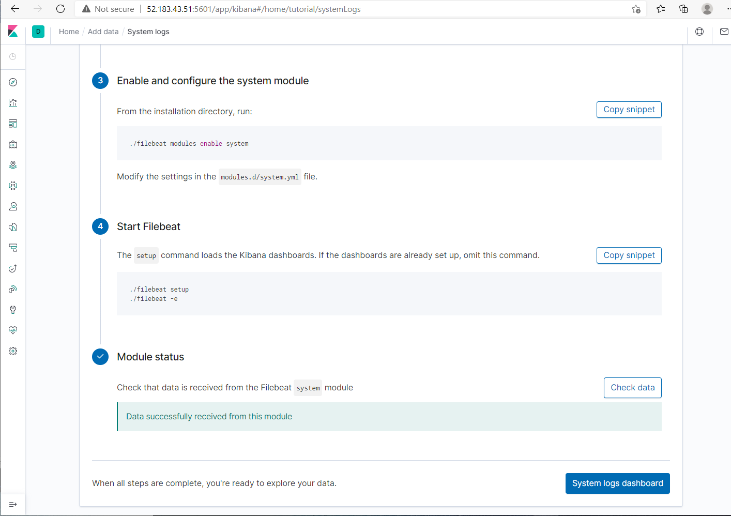

The screen shots below show the system log dashboard from the successful running of the filebeat:

